CTLS Learn

Go to http://ctlslearn.cobbk12.org/

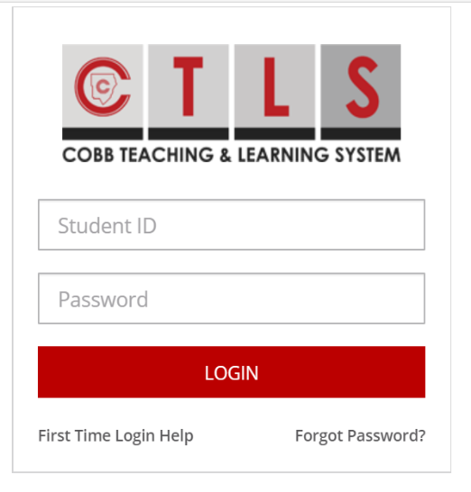
Student ID: firstname.lastname@students.cobbk12.org
For password, use the password you use to get on the computer at school

You might also need to know your Office 365 username.
You can find it by logging into StudentVUE and looking here:
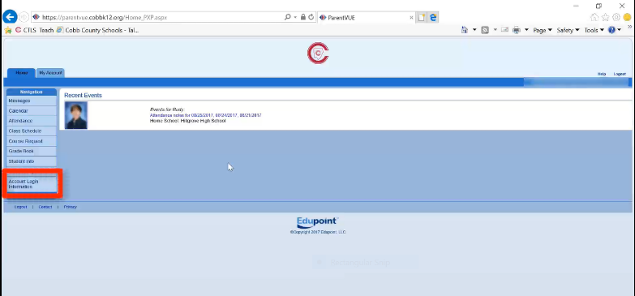
It will look like this: firstname.lastname@students.cobbk12.org

***Please note***
Your password should be the same for StudentVUE, CTLS, Office 365 & to log into a school computer.
If your password is not working, please fill out a request to change your password by clicking here.

