Causes and Consequences of the Great Depression

While many European nations suffered a post-World War I recession, the United States did not. American businesses, farms, and banks profited greatly during World War I by selling products to European markets. However, by 1929, the economic boom for the United States was over and the worst economic crisis in U.S. History began, the Great Depression. There are numerous causes that together led to the severity of the Great Depression.
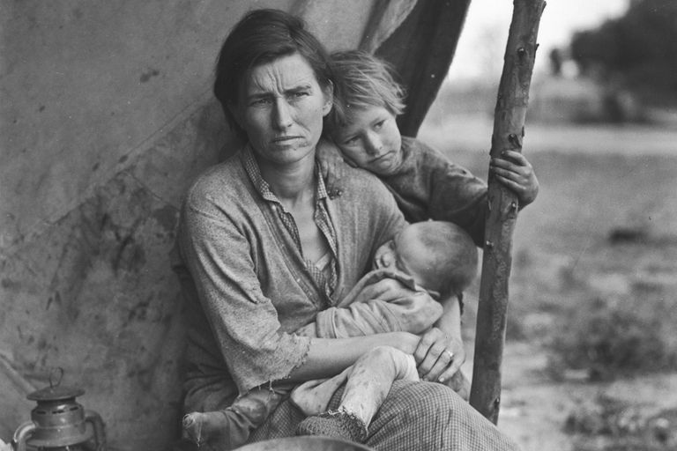
1. The greatest economic crisis in history is known as the ________________________________.

Industries increased their productive capacity to produce and sell more goods. As a result, a supply surplus was created. This problem became exacerbated by Europe's struggling post-war market. The European countries could not buy as much American made product due to their own financial difficulties. The United States had more goods than consumers, and this resulted in industrial overproduction.

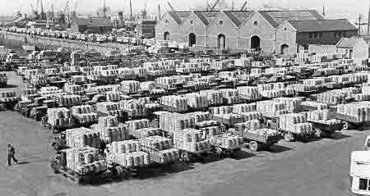

2. ________________________ led to a surplus
(products left on the shelves) of goods and few consumers.

With cash to spend after the war, Americans went on a spending spree. The development of the national consumer market in the United States and the advent of consumer credit further encouraged spending, which led to consumer overspending. After the Stock Market collapse in October 1929, consumers quit spending except for absolute necessities creating a surplus of goods in the market place. This caused Under-consumption, which deepened the economic slowdown.
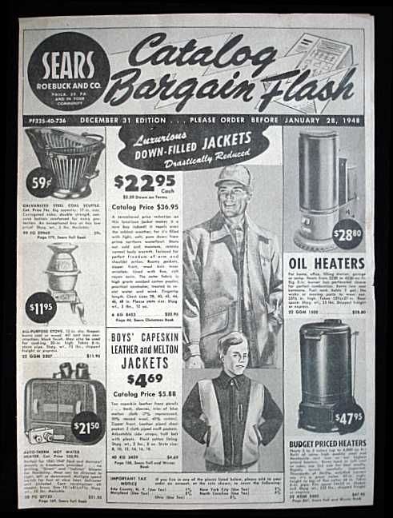

3. What caused consumers to stop spending at the end of the 1920s?

Banks loaned people money to buy stock with very little money down. The stocks themselves became the collateral for the loan. This was called buying on margin. Rising stock prices and the ability of ordinary people to buy stock on credit increased investment in the stock market and inflated the price of stocks above their actual value. Then, by October 1929, the U.S. economy was beginning to show signs of slowing down. Stockholders feared the economy was ending a period of prosperity and entering a period of recession. This caused some investors to panic and sell their stocks. As more people sold their stock, other people panicked and sold their stock as well, driving down their prices and causing a stock market crash.

4. The ____________________________ resulted when people panicked and sold their stock.
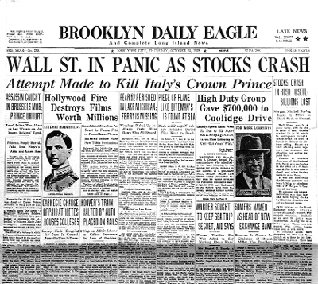

During the 1920s, the wealthy grew wealthier due in large measure to government fiscal policies that both reduced business regulations and allowed the wealthy to keep more of their money. These reduced regulations and low corporate taxes increased the profits of corporations and made their stocks more valuable. At the same time, the poor and working classes lost the ability to buy products because their wages stayed the same while prices rose, the result of a gap between the rich and poor. This resulted in business overproduction and eventually caused business profits to decline.

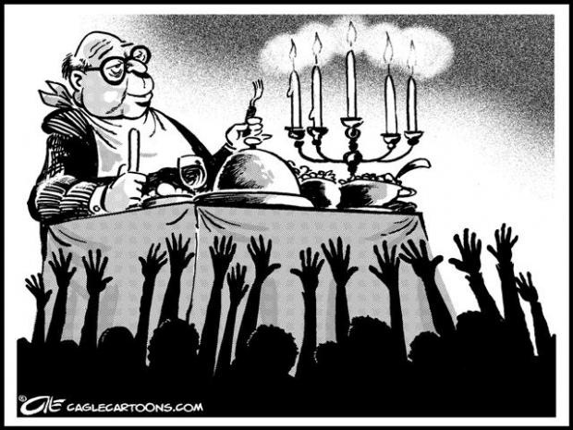

5. The gap between the _____________ and _______________
resulted in business overproduction and business profits to decline.

As unemployment increased, depositors began to withdraw more and more of their savings from their bank. Lacking sufficient reserves, banks were forced to call in loans, which in turn touched off a wave of bankruptcies. Unable to collect outstanding loans, banks began to fail. In all, 9,000 banks failed during the 1930s. Many people lost their life savings. The bank failures led to a demand for more cash in the economy, which contradicted the Federal Reserve policy of the era. The banking panic led to a shortage of cash in circulation worsened the effects of the economic downturn.

6. The ___________________ led to a shortage of _______________ in the economy.

With all of these factors in play simultaneously, the Great Depression began and continued to get worse. A capitalist system naturally has dips in the economic cycle. However, the events of the 1920s (overproduction, under-consumption, and the Stock Market Crash) made the crisis far more severe than a normally occurring downturn.
New machinery and improved farming techniques made American farmers very productive. By producing more food each year, farmers thought they could earn more money. Instead, this overproduction helped drive down the prices of their products and made it harder for them to make a profit. In response, farmers tried producing even more food by taking out more loans to buy more land and farm equipment. As a result, most farmers were very vulnerable to economic and environmental disasters when banks started foreclosing on farms owned by farmers unable to repay their loans. To make matters worse, the Great Plains states were experiencing a severe drought. When a series of severe dust storms hit the prairies, they picked up the dirt loosened by the drought and the poor farming practices that had eroded the soil. This ecological disaster was called the Dust Bowl. Dry conditions and high winds made farming impossible. Tenant farmers and sharecroppers were among the hardest hit as their landlords evicted them and sold the land. Over 500,000 Americans were left homeless. Many farmers from Oklahoma, Texas, and the surrounding Dust Bowl states migrated to California in search of work.
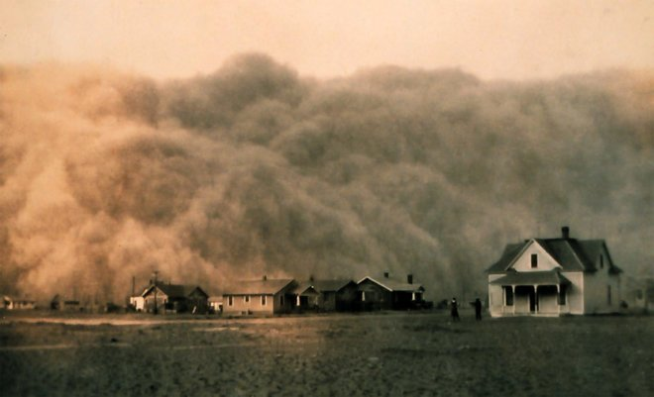

7. The ___________________ was caused by agricultural
overproduction, overfarming, and drought.

As profits fell and it became clear consumers would need to reduce spending, workers began to lose their jobs. By 1932, the unemployment rate in the United States had reached 25%. Unemployed workers who had no savings could not pay their debts, and many lost their homes. Homeless and unemployed people settled in camps of shacks and tents in rundown areas. These camps became known as Hoovervilles, named after Herbert Hoover, the U.S. president when the Depression started (Due to his lack of involvement in helping the issues). Hooverville residents slept in packing crates if they were lucky; if not, they slept on the ground. They begged for food from people who still had jobs and housing. Desperate Americans stood in bread and soup lines for hours to get food.

8. Workers lost their _________________ when profits fell.

9. Americans lived in homeless shacks, known as ________________________, named after President Hoover (many Americans felt he wasn’t helping them)

10. What would Americans do when they were desperate for food?

