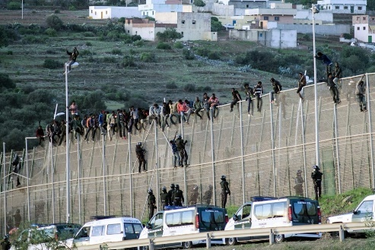
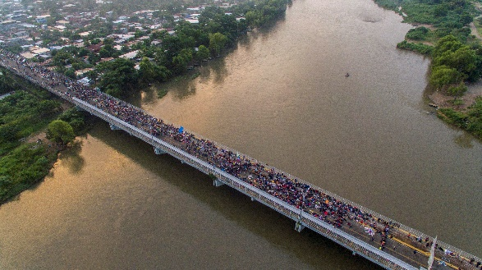
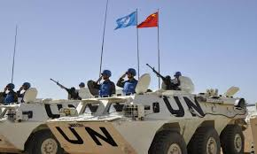
Political Geography Project – Boundaries, Borders, and Conflict

Step #1: Choose one border issue from the list below.
- Haiti / Dominican Republic – One Island, Two Worlds
- The Arctic – Russia’s Plan For The World’s Newest Ocean
- Japan / North Korea – How A Group Of Children Got Stuck Between Two Nations
- Mexico / Guatemala – How The US Outsources Border Security
- Spain / Morocco – Africa’s Gateway to Europe
- Nepal / China – How Mountains Become Borders

Step #2: Choose HOW you will create your project.
You can create your Political Geography Project with any illustrative medium you prefer: Sway, Canva, Google Slides, etc. You can also make it by hand and submit a picture of it if you choose.

Step #3: Begin your research.
Use the following link to begin your research:
https://www.vox.com/a/borders
* If you go to this page and scroll down, you can find links to each of the border issues where you can watch videos and learn more about each border issue.

* If you use additional sources for research, make sure to write down the FULL LINKS to all of your sources (ex. https://www.cbsnews.com/news/fortified-morocco-spain-border-fence-is-under-pressure-from-african-migrants/ NOT just cbsnews.com).

* Citing Google will not earn credit for sources. You should include ALL sources at the end of your project.

Step #4: Assemble the content for your project.
Here’s what you want to make sure you include in your project:
- The countries involved (Example: Mexico and Guatemala)
- Briefly explain the history behind the creation of the border. (Example: When was the border defined? Have there been any changes to the border? Are there disputes about the border?)
- Describe how the border impacts the countries involved:
- Socially (the way people interact)
- Politically (how the government is organized / political ideas and beliefs)
- Economically (how money and resources are used)
- Environmentally (how it affects the environment)
- Demographically (the make-up of the population – age, etc)
- Provide any other basic geographic or historical information important to explaining why this border issue exists. This can be something that you saw from the video that you feel is relevant.
- Include relevant images (at least 3).

Step #5: Create and refine your Project.
Organize the required elements into a dynamic design that captures the attention of your viewer and informs the reader. YOU WILL NOT EARN CREDIT FOR COPY & PASTE PLAGIARISM. Be careful of copying your sources too closely. Put it in your own words. You can use quotes, but make sure to credit who said it and the link to the source at the end. You will earn credit for the content and creativity of your project.

Review the success criteria before submitting to make sure you earn full points. Also, look for the opportunity to earn extra credit.
Success Criteria
Accurate information included; includes the following content  - Countries involved  - History behind creation of border  - Impact of border (social, political, economic, environmental, demographic)  - Other basic geographic information important to explain why this border issue exists | ____ / 60pts.
At least 3 relevant images provided in design;  design is engaging and well organized | ____ / 30pts.
Sources included (full links, and no Wikipedia) | ____ / 10pts.

