Post World War I Events

Social changes seen during the war led to two constitutional amendments. Americans’ anti-German feelings led to a campaign to outlaw beer and other alcoholic beverages. This campaign well suited the Progressive Era’s opposition to saloons. Congress passed the Eighteenth Amendment, which prohibited “the manufacture, sale, or transportation of intoxicating liquors.” Ratification of the Nineteenth Amendment, which gave women the right to vote, was helped by the country’s gratitude for women’s economic contributions during the war. The women had filled jobs in factories after men volunteered and were drafted into military service.
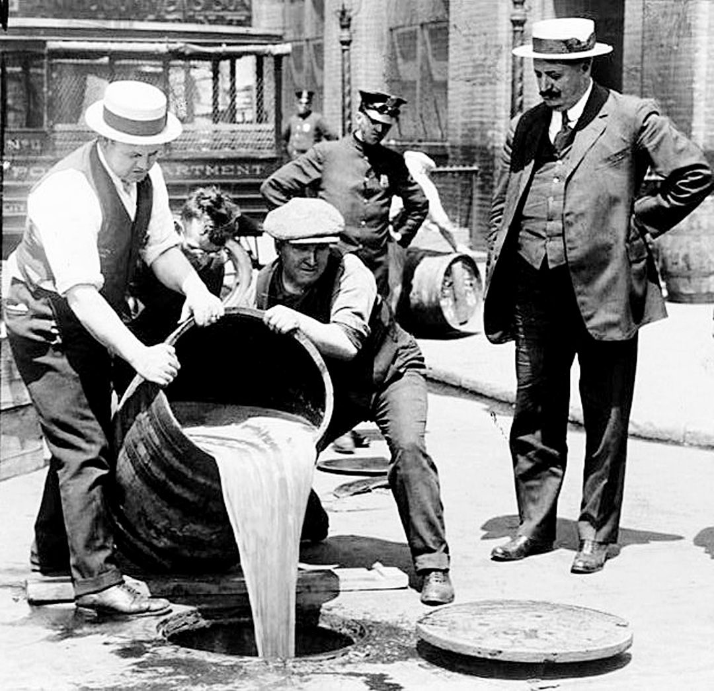
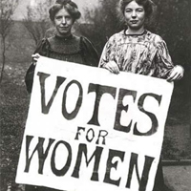

Isolationism
Before the United States entered the war, Wilson gave a speech in which he described
Fourteen Points he felt were key to avoiding future wars. One point called for the creation of an international peacekeeping organization called the League of Nations.
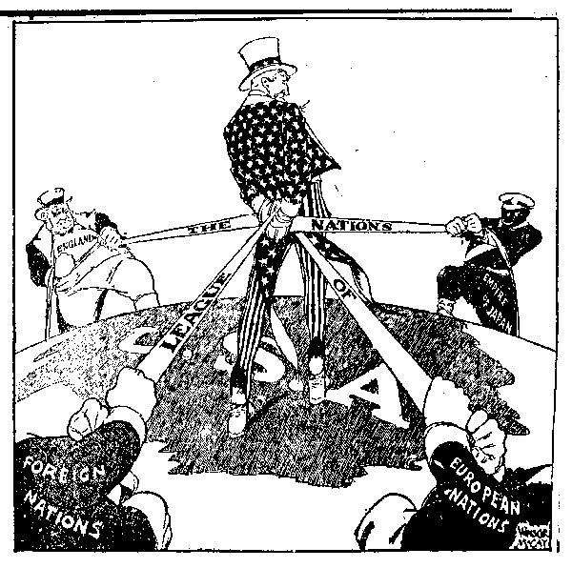

During the postwar treaty negotiations, Wilson worked hard to get as many as possible of his Fourteen Points included in the treaty and succeeded in securing the creation of the League of Nations. However, American opposition to the League of Nations ultimately led the Senate to refuse to ratify the treaty. Isolationists in the Senate believed that by joining the League the United States would become involved in future conflicts in Europe and elsewhere. Though Wilson traveled across America to create public support for the treaty’s ratification, the Senate eventually rejected it. The United States never joined the League of Nations.

In the decade after World War I, conservatives in the country tried to impose their image of America on the nation, while a new generation of young people challenged traditional values and authority on social matters. This standard will measure your understanding of the social issues experienced in the 1920s.

Communism and Socialism
In the late 1800s and early 1900s, a new political ideology called communism grew out of the more moderate socialism. Communism was based on a single-party government ruled by a dictator. Under communism, there is no private ownership; all property is owned by the state. In 1919, after communist revolutionaries known as Bolsheviks overthrew the czar in Russia, established the Soviet Union, and called for a worldwide revolution to destroy capitalism, people in the United States began to fear communists. This fear of international communism was called the Red Scare because red was the color of the communist flag. This fear led to the government’s pursuit of suspected communists and socialists.
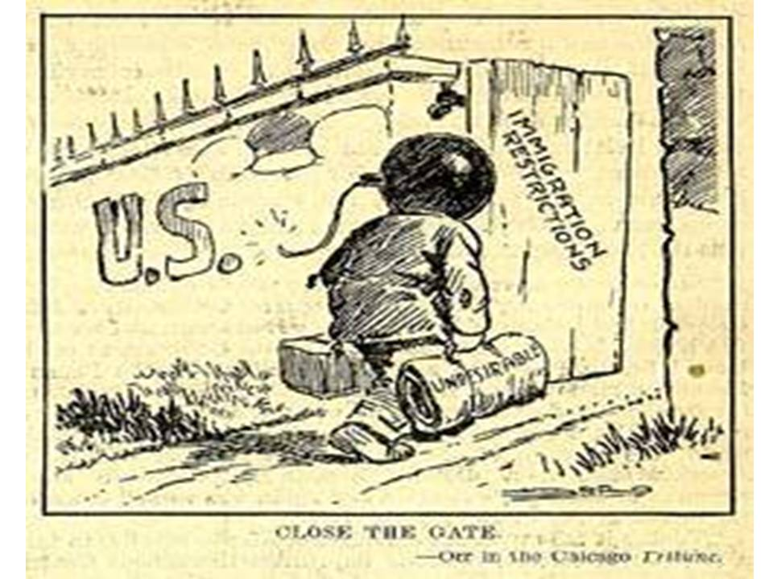

Immigration Restrictions
The Red Scare was one factor that led to new restrictions on immigration. Other factors were two ideas that grew strong in America in the 1920s. One of the ideas was that people born in America were superior to immigrants. The other was that America should keep its traditional culture intact. Anti-immigrant, anti-Jewish, and anti-Catholic sentiments contributed to the popularity of a revived Ku Klux Klan, not just in the South but throughout the nation. Ultimately, this conservative reaction against immigrants resulted in the passage of legislation that set limits on the number of immigrants who could come from each country.

Questions:

- The Eighteenth Amendment passed:

  - The prohibition of alcohol
  - Gave women the right to vote
  - Prohibited women from voting
  - Gave the right to Americans to sell alcohol

- What was Wilson’s 14 Points Plan?

- Was the League of Nations ever passed by the U.S.?

- What is communism?

- What was a result of the Red Scare?

- What were the reasons for immigration restriction?

