The Roaring Twenties
SSUSH16 Investigate how political, economic, and cultural developments after WW I led to a shared national identity.
a. Explain how fears of rising communism and socialism in the United States led to the Red
Scare and immigrant restriction.
b. Describe the effects of the Eighteenth and Nineteenth Amendments.
c. Examine how mass production and advertising led to increasing consumerism, including
Henry Ford and the automobile.
d. Describe the impact of radio and movies as a unifying force in the national culture.
e. Describe the emergence of modern forms of cultural expression including the origins of
jazz and the Harlem Renaissance.
Name, Event or Concept | Leading Questions
Henry Ford | 1. What did Henry Ford produce in his factories?  2. Ford transformed American manufacturing by innovating the production process. What does “mass production” mean?  3. What was the name of the first mass produced American automobile?  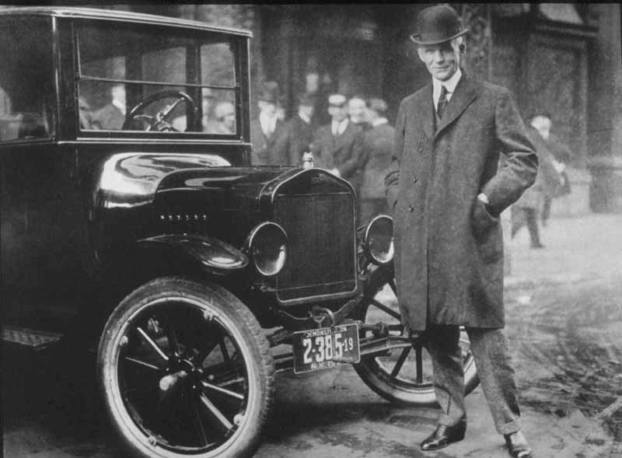  4. How was Ford able to produce Model T’s quickly and efficiently?
A Bustling Economy | 1. The 1920’s saw a “consumer revolution”. What was a consumer revolution?  2. Why was there an abundance of credit available to consumers?  3. During the 1920’s, many people invested in the stock market by purchasing company stocks “on margin”. What does it mean to “buy on margin”?
The 18th Amendment Establishes Prohibition | 1. Define “prohibition”:  2. What did the 18th amendment to the Constitution outlaw?  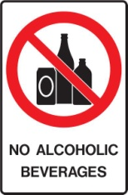  3. How did Prohibition impact the lives of everyday citizens?
The 19th Amendment Grants Women Suffrage | 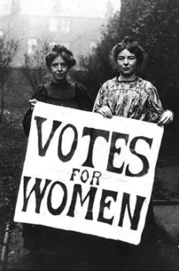  1. Define “suffrage”:  2. What did the 19th amendment to the Constitution allow?  3. Identify one reason for the growing political/economic  importance of women in the 1920’s.
The Impact of Radio and Movies | 1. What did many Americans do with their extra “pocket money” during the 1920s?  2. Identify three impacts of the radio:  a.  b.  c.  3. Which groups of people replaced politicians as “celebrities” in 1920s America?  a.  b.  c.
The Jazz Age and Louis Armstrong | 1. Define “jazz” music:  2. In which US city did jazz originate?  3. Who was one of the most famous jazz musicians of the era?  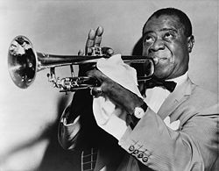
The Harlem Renaissance and Langston Hughes | 1. What is a “renaissance”?  2. Where is Harlem?  3. What happened during the “Harlem Renaissance”?  4. Who was Langston Hughes?  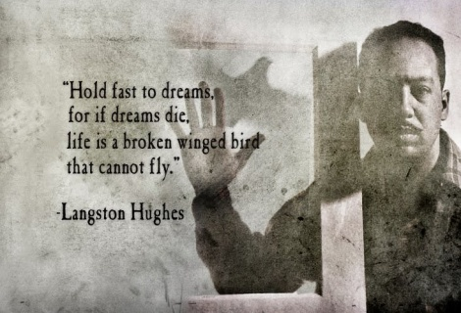  5. What effects did the Harlem Renaissance have on American society?  a.  b.
Tin Pan Alley and Irving Berlin | 1. What and where was Tin Pan Alley?  2. Why was there a high demand for music composers in the 1920s?  3. How did the radio impact Tin Pan Alley?  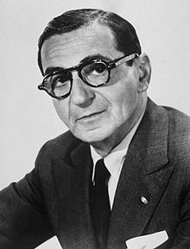  4. Who was Irving Berlin?  5. Identify three “classics” penned by Irving Berlin:  a.  b.  c.
“Blue Skies” (1927) Written by Irving Berlin

I was blue, just as blue as I could be
Ev'ry day was a cloudy day for me
Then good luck came a-knocking at my door
Skies were gray but they're not gray anymore
Blue skies
Smiling at me
Nothing but blue skies
Do I see
Bluebirds
Singing a song
Nothing but bluebirds
All day long
Never saw the sun shining so bright
Never saw things going so right
Noticing the days hurrying by
When you're in love, my how they fly
Blue days
All of them gone
Nothing but blue skies
From now on
Blue skies
Smiling at me
Nothing but blue skies do I see

I hear those little blue birds
They’re singing a song
Nothing but blue birds
all day long

I never felt my heart beating so fast
Cause I’m in love, I’m happy at last
I’m sitting on the world, wearing a grin
Telling the clouds that I’m not in

Blue days, blue days
All of them gone…gone…gone
Nothing but blue skies
From now on…

